Solutions to “vagrant up” Hangs at “ssh auth method: private key”

**[2](https://terryl.in/en/vagrant-up-hangs/" \l "comments)**

 [**Terry Lin**](https://terryl.in/en/author/terry/) written 1 year ago



Hello, guys. Did you ever meet some strange issues when booting your VM by using Vagrant? My case is that when I execute vagrant up to boot my VM, it takes very long time and hangs at ssh auth method: private key。

The console messages look like this:

$ vagrant up

Bringing machine 'default' up with 'virtualbox' provider...

==> default: Clearing any previously set forwarded ports...

==> default: Fixed port collision for 22 => 2222. Now on port 2200.

==> default: Clearing any previously set network interfaces...

==> default: Preparing network interfaces based on configuration...

default: Adapter 1: nat

default: Adapter 2: hostonly

==> default: Forwarding ports...

default: 22 (guest) => 2200 (host) (adapter 1)

==> default: Running 'pre-boot' VM customizations...

==> default: Booting VM...

==> default: Waiting for machine to boot. This may take a few minutes...

default: SSH address: 127.0.0.1:2200

default: SSH username: vagrant

default: SSH auth method: private key

And then stuck.

After wasting hours and hours of time researching this issue, I ended up finding solutions to this kind of issue.

Below are the solutions that may solve this problem, you can try one of them, or all of them, until the problem is solved.

**Solutions**

**Increase timeout**

Add this line in your Vagrantfile.

config.vm.boot_timeout = 300

**Check network setting**

Make sure that your VM has the Cable Connected setting checked. This setting is in Network tab of the VirtualBox GUI.

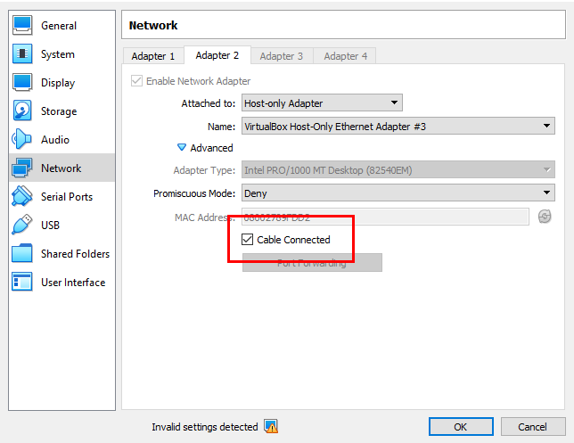

Or simply add the following line in your Vagrantfile to turn Cable Connected on.

config.vm.provider "virtualbox" do |vb|

vb.customize ["modifyvm", :id, "--cableconnected1", "on"]

end

**Turn Hyper-V off**

For Windows users only.

Hyper-V is the windows server virtualization that can create virtual machines on x86-64 systems running Windows, and it can not run with VirtualBox together, so we need to turn off it.

First step, find **Turn Windows fetures on or off**

Move on to Control Panel -> Programs, under Programs and Features section, click the link as shown in the screenshot below.

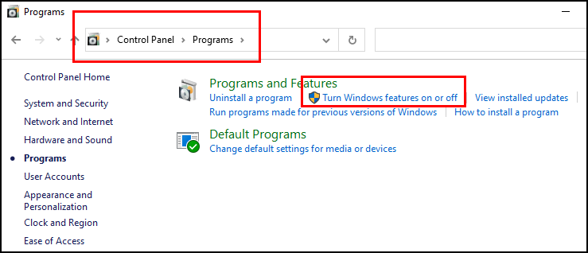

Okay, now make sure that "Windows Hyperviosr Platform" is unchecked. Also, "Virtual Machine Platform" is checked.

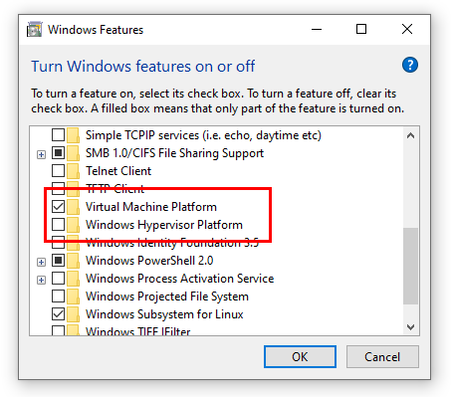

Windows Hyperviosr Platform: Unchecked

Virtual Machine Platform: Checked

Click the OK button and then reboot.

And few more options disabled as follows.

1. Containers
2. Hyper-V
3. Virtual Machine Platform
4. Windows Hypervisor Platform
5. Windows Subsystem for Linux

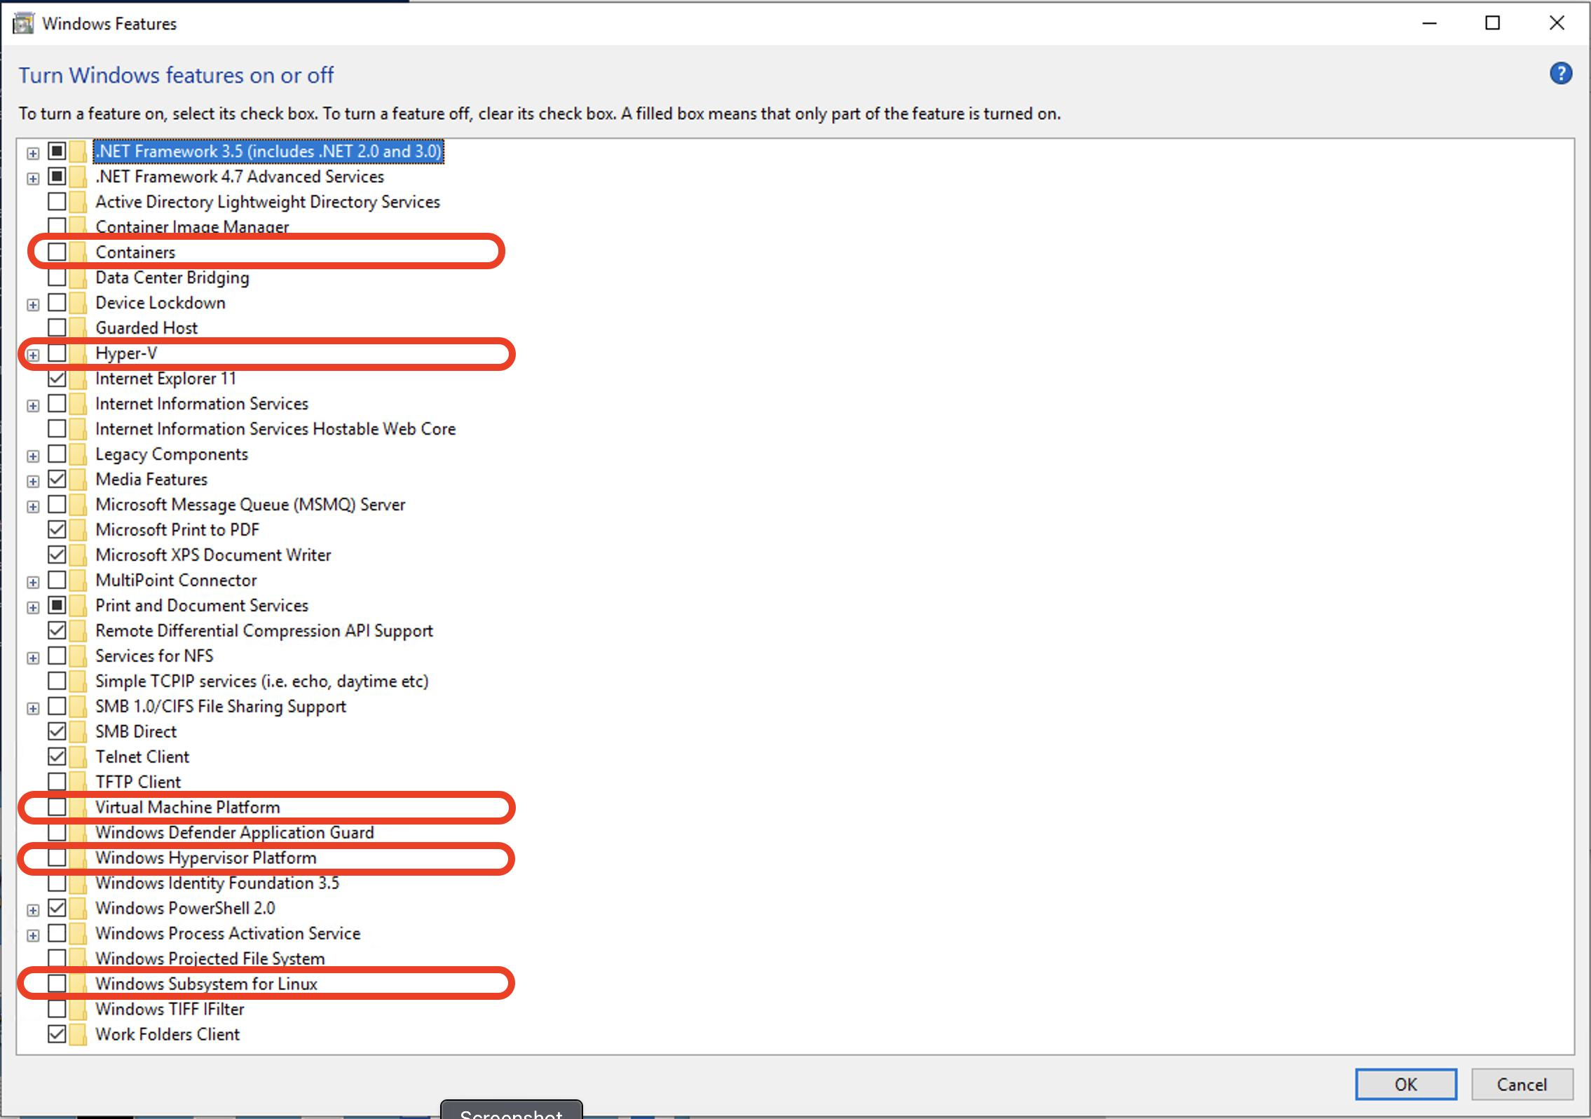

**Check BIOS setting**

Enable the hardware virtualization in BIOS (VT-x), which is required on Windows OS to run any kind of virtual machine.

**Click on VM Preview**

Open the VirtualBox UI for the VM your are running, the screenshot may look like this.

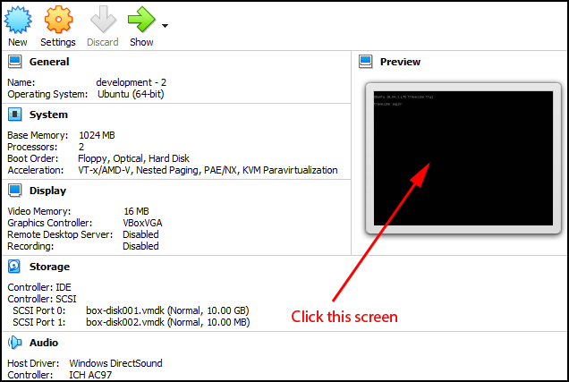

If the GUI is not shown, add gui = true in the Vagrantfile and try again.

config.vm.provider "virtualbox" do |v|

v.gui = true

end

Click on the Preview window and press **Enter** key to make system continue to boot. And then you can see the vagrant up going on.

**Bug for bionic64**

If you are using the box ubuntu/bionic64 and having the same problem. There is a [confirmed bug](https://bugs.launchpad.net/cloud-images/+bug/1829625) that causes some of the newer Ubuntu boxes to boot slowly, which is causing the SSH timeout. Adding the following settings in your Vagrantfile may help.

config.vm.provider :virtualbox do |vb|

vb.customize ["modifyvm", :id, "--uart1", "0x3F8", "4"]

vb.customize ["modifyvm", :id, "--uartmode1", "file", File::NULL]

end

**Conclusion**

Hope this post helps and saves your time 🙂